Week 9. Elevator One (freight elevator)
We will wire and code a simple elevator for a 4 story building. The elevator will move via a servo - in response to a button on each floor and four buttons within the elevator. Begin by wiring, in Tinkercad, the circuit below. Use the big board to make room for future work.
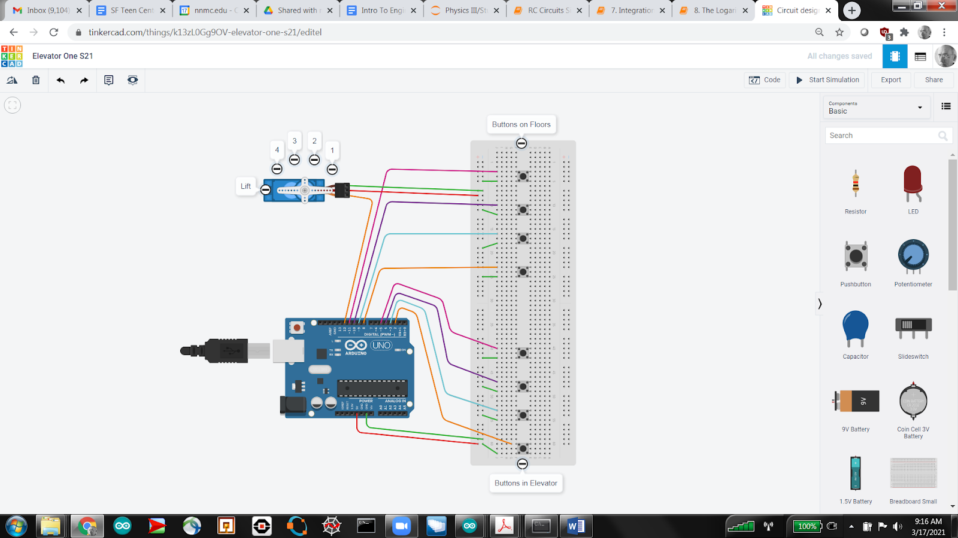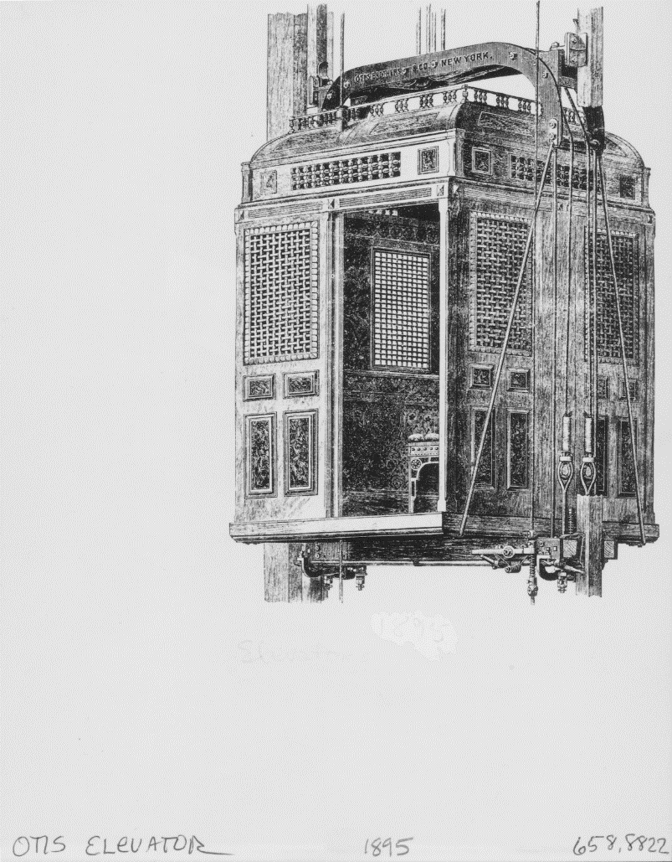
Modern elevators have very complex logic. We will start with something simple, more akin to a freight elevator. Does this logic make sense to you?
- Wait for a Floor Button push
  - Go to that Floor
- Wait for an Elevator Button push
  - Go to that Floor
- Repeat
Here is a video of how your finished project should function.
Pushbuttons work just like our tilt sensor, we declare each associated pinMode to be INPUT_PULLUP, so that their unpushed state is HIGH, and then we act when they go LOW.
We will be working in text code from now on. Note that as you switch from block to text it gives you both the setup procedure and the loop procedure - with ALL commands in between the respective open and close braces, { }.
Please create the preamble (with the necessary code for a servo called Lift).
Next fill in the setup procedure with
- the servo attachment,
- set your servo to start at angle 36.
- declare the pinMode of each of your pushbuttons
To code this we make two new variables, add
int Fcall, Ecall;
to your preamble and use the while loop in your loop routine.
In particular, I recommend
- Fcall = 1
- while Fcall == 1
  - If floor button 1 is pressed (LOW)
    - Move to floor 1 (servo angle 36)
    - Fcall = 0
  - If floor button 2 is pressed (LOW)
    - Move to floor 2 (servo angle 72)
    - Fcall = 0
  - Similar set up for next two floors (servo angles being multiples of 36)
- Ecall = 1
- while Ecall == 1
  - Same as above (but setting Ecall = 0 instead)
Just as all control functions in block-code share the same horse-shoe structure, these control functions in text-code share the same clause structure - but require careful distinction between parentheses and braces.
For example, EVERY while statement looks like
while ( condition ) {
action
} // close while

Please understand that condition and action are NOT to be literally typed, they are proxies for YOUR particular conditions and actions. The condition is what we placed in the hexagon at the top of the horse-shoe, and the action is what we placed “inside” the horse-shoe.

Likewise, EVERY if statement looks like

if ( condition ) {
action
} // close if

And EVERY for statement looks like

for ( condition ) {
action
} // close for

This for loop is the text version of the repeat block we used in our SOS code. We will use it repeatedly in our elevator work. It will save us from having to repeat very similar commands.

For example, rather than sequentially declaring each of the pushbutton pins, we can loop them,

int i;
for ( i=0; i<4; i=i+1 ) {
pinMode(2+i, INPUT_PULLUP);
}

We see that this loop uses an integer counter variable, i, and that condition takes on the three part form
start; stop; increment
That is, we tell our counter
- where to start,
- where to stop, and
- by which increment to count
being careful to place those two semicolons after the start and stop conditions.

With this introduction, you should now be able to see that our main loop routine consists of two while loops, one for floor buttons, the other for elevator buttons. In particular, the structure of each while loop is
while ( condition ) {
for ( condition ) {
if ( condition ) {
action
} // close if
} // close for
} // close while

Where the conditions and actions are those necessary to sense and act like an elevator. These are explained above and, as with the bridge, should comport with your own experience of using an elevator.

